English 102: Writing through Literature

Course Time and Place: Mondays, Wednesdays, Fridays, 8:00 am - 9:00 am, E-260
Instructor: Professor J Polish
Office hours: By appointment
Email address: jpolish@lagcc.cuny.edu
Course Blog URL: http://cunyhumanitiesalliance.org/writenow/

Dear Writing Through Literature Students,

Welcome to English 102. I’m excited to get to know all of you through our class and writing this term. This syllabus draft is your guide -- your roadmap -- to how our class will go. If you have questions about class logistics, this is the first document you should check. However, because I want you to contribute heavily to how our class operates and how we work together, this syllabus is also a draft, a living document: it will change throughout the term according to your needs and wants and suggestions.

You all have access to commenting directly on this document through google docs at the link below and I encourage you to do so throughout the term whenever you have suggestions, questions, edits, or insights. https://docs.google.com/document/d/12B8Uc-_NpijR2vU9LALJgGXu9VObR_98X1KAoY1QCd4/edit?usp=sharing

If and when substantial you (or I) make substantial changes to this document, I’ll let you know in class and the updates will be posted on our class blog at the address listed above.

Please check our blog when you can, especially if you can’t attend class, as a lot of class communication will happen there. If you have trouble accessing the internet on a regular basis, please let me know as soon as possible and we will make sure you get what you need.

As you read through this syllabus, please think about:

When and why do you write in your everyday life?

Has a piece of writing ever changed you somehow? (Remember that someone writes TV shows and movies and SnapChats and text messages, too!)

How does writing -- and its flip, reading -- help us to breathe in times of crisis and in times of celebration and the times in between?

What does writing allow us to create, and what does writing allow us to resist?

What solace can writing create for us?

It is very important to me that our class is as accessible as possible for everyone in it. This means that if I’m ever using language that is not easily understandable, or am speaking too quickly, or am generally coming up short in my responsibility to help you learn the best you can, I always encourage you to let me know in any way that you can (saying something during class, notes, emails, in-person, etc.).

Additionally, if any factors you cannot control — public transportation availability/safety, family safety in the midst of changing immigration policies, etc. — are interfering with your ability to benefit from this class experience, know that there are many resources available to you through LaGuardia.

Some of these resources are housed at the Wellness Center (discussed below and linked here: http://www.laguardia.edu/WellnessCenter/) and others — including legal counseling, financial assistance, health care enrollment, etc. — can be accessed through Single Stop (linked here: http://www.laguardia.edu/singlestop/).

What can you access through Single Stop?

SINGLE STOP:

Single Stop USA has partnered with LaGuardia Community College to connect students with federal and state financial resources, and local community services to overcome financial barriers, stay in school and graduate. Single Stop provides financial assistance with daily living expenses, e.g. pay for doctor’s visits, medications, food, rent, utilities, child care, transportation and more! All of our services are free for LaGuardia students and their immediate family members.

Do I qualify for benefits?

If you answer “yes” to any of the questions below, you may qualify for additional financial services and/or benefits:
- Do you need help paying for college?
- Are you finding it difficult to meet basic living expenses such as for housing, food, rent, clothing, etc?
- Are you receiving limited or no financial support from your family?
- Are you financially responsible for children under the age of 24?
- Are you a veteran?
- Are you in need of financial assistance?
- Are you undocumented?

http://www.laguardia.edu/singlestop/#

You can also access free and confidential immigration assistance is available through CUNY Citizenship Now, linked here: http://www1.cuny.edu/sites/citizenship-now/ and CUNY CLEAR, linked here: http://www.cunyclear.org

If you or any of your loved ones need information on the recent DACA decision, the infographic below (from https://sandalwoodandsunlight.tumblr.com/post/165015087823/weareheretostayorg) is equipped with information from weareheretostay.org that you might find useful.
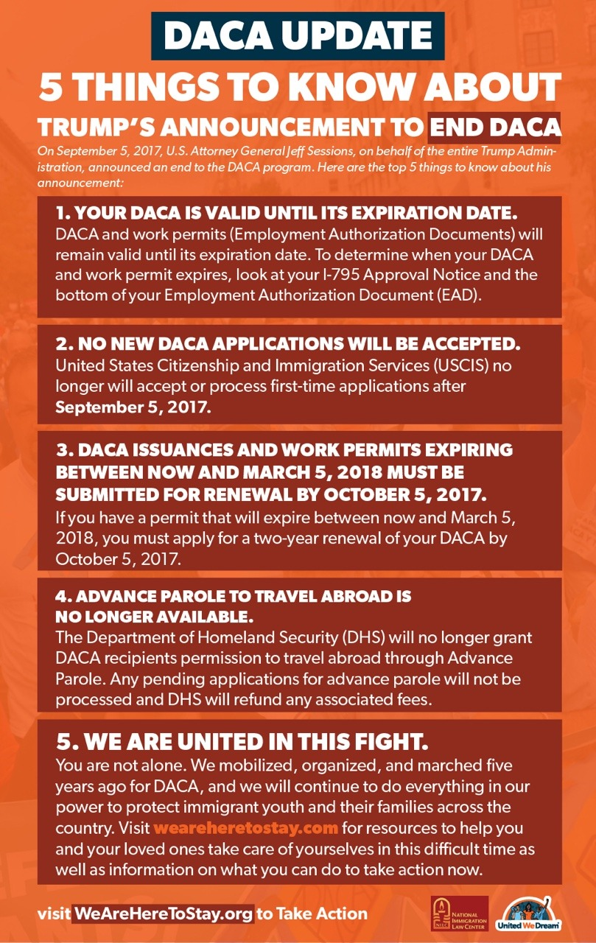
An infographic about 5 Things to Know about 45’s Announcement to End DACA, info from http://weareheretostay.org/resources/daca-update-five-things-you-should-know/

In addition, dis/abilities — ranging from anxiety to chronic pain — often go un-discussed in classroom settings, but my goal for this class is to foster a generative learning environment for each student: if I am not succeeding at this, please let me know so that I can make the necessary changes. As I will repeat throughout the syllabus, if you anticipate needing any kind of modification to the class as structured, please let me know as soon as possible.

This includes the ability to draft a separate grading contract with me if you know that any component of the contract is going to be overly burdensome or impossible for you to achieve due to life circumstances or any dis/ability you might experience. Additionally, if you have a documented learning, sensory, physical, or other reason for needing any kind of special accommodation in this class, contact the The Wellness Center in room C-249, email WellnessCenter@lagcc.cuny.edu, and phone 718-482-5471. Please feel free to reach out to me for additional assistance.

Course Description:

In this class, we’ll be exploring (at least) three different genres of literature: poetry, drama, and comic books. You will receive your own copy of Ms. Marvel (for free), and the other readings will be available both on the course blog and in a course packet that I will provide for you.

The spoken word poems that we explore will focus on the meaning of language and expose to us the ways that language can be used to transform words into action.

The theatre piece that we will examine next is called Anon(ymous), a play by Naomi Iizuka about a young refugee named Anon who searches for his family in the United States.

Finally, we will dive into comic books, focusing on Ms. Marvel, which stars a young Pakistani Muslim woman who becomes a powerful superhero in New Jersey.

We will study each of these genres for three weeks; every fourth week, you all will bring in texts for your classmates and me to explore. These texts can range from YouTube videos to published poems and excerpts from novels to a short story you wrote last year and never showed anyone; as long as you are inspired to think about these texts by our class discussions, they’re fair game.

Through reading/exploring all these pieces of literature, we will not only sharpen our skills at analyzing literature and its impact on the world around us, but we will also explore the power of generating literature of our own.

How can literature -- our literature -- impact movements toward racial justice in a country currently overrun by racist ideologies and policies?

Course Objectives:

At the end of this course, we will all (myself included) gain a greater understanding of:

- The collaborative and individual processes of pre-writing, drafting, revising, editing, proofreading, and sharing writing.
- Different methods of analyzing pieces of literature from diverse sources and genres.
- Research methods that will assist us in reading closer and writing richer texts.
- Using our own cultural and individual language styles to integrate into and disrupt dominant expectations of what literature is.
- The importance of entering dialogues with other scholars and artists through ethical citation methods and MLA-style citation.

Course Assignments:

In addition to participating in blog discussion forums with your classmates, in English 102, you will have four major writing assignments in which you will create your own pieces of literature/art/analysis:

- An analysis of a spoken word piece;
- An research essay analyzing Anon(ymous);
- An analysis of Ms. Marvel; and
- An in-class essay.

You will have to create a 600-word analytically reflective artist’s statement regarding what you learned, what you didn’t learn, how you can use what you learned, etc., with assignments one and three.

For assignments one and three, you will choose the format of your piece from the following list of choices (for assignment one, you will choose from one category; for assignment three, you will choose from a different category). Below, each link contains an example or a how-to of the format listed. Have fun with your choice!

Visual
Video/documentary-style
Music video
Reaction video/vlog
Drawing
Painting
Sign/poster
Comic

Auditory
Podcast
Music mix/mashup
Musical performance
Spoken word

Tactile
Map/diagram
Performance
Sculpting
Conceptual set design
Improv performance
Create a game

Written
Poem
Fan fiction
Blog post
Comic
Personal essay
Analytical essay
Short story
One-act play
Monologue

Action
Website action
Letter
Blog post
Campaign
Workshop
Street theater
Community work
Toolkit

Assignment Expectations:

Before each assignment is due, you will get a hard copy and two online copies (on the course blog and Google Docs) of the specific expectations. Before each assignment is set, we will always have the opportunity to review these assignments in class together. Further, you will be encouraged to edit/comment on the assignment parameters on Google Docs to make sure everything is crystal clear and that you get to shape expectations.

Through this process of shaping our expectations, I’d like to share something that is important to me. Education is often designed for people who already have access to education: academic writing is designed by and for people who have experience with… academic writing! Perhaps you’ve experienced this in your previous courses/school work. This racialized power that accompanies language -- allowing white professors, like me, access to a world that many students, especially students of color, are often denied access to -- is important to discuss, and we will be doing this a lot in our class. In the same way that I want you to feel empowered to correct me if course materials aren’t accessible in terms of learning styles and dis/ability, please do so also if there are culturally relevant methods that would help you learn better that I am not thinking of or currently valuing.

In addition to this, there are a few things each of the assignments will have in common:

Each assignment will require you to submit pieces of your thoughts -- drafts -- in advance of the due date, and these are extremely important. They do not have to be perfect -- far from it! -- but these drafts will be a very important part of our work together. Importantly, you have to annotate each of your drafts with specific questions for me and for your peers!

For each draft, you will review and comment on the work of one or more of your peers. These reviews are crucial, not only to help you and your peers experience each other’s writing processes and make each other’s projects stronger, but to build the kind of collaborative writing environment that will make our classroom a generative space.

Each assignment portfolio (including your peer reviews, your revisions, and your due date copy) must be submitted with a short artist’s statement that you create after completing the assignment, in which you will reflect critically on your own process of creation.

Participation:

Participation and attendance are very important parts of this class: the classroom is where we will do much of our learning, writing and collaborating. For the LaGuardia Community College requirements for participation and attendance -- which is very important for financial aid! -- please see page five of this document: https://www.laguardia.edu/uploadedfiles/main_site/content/academics/catalog/pdfs/academicrequirementsandpolicies.pdf

Participation -- and even attendance -- can mean different things to different people, at different times, and not everyone is comfortable or able to participate and attend classes in the same way. So, if you anticipate or develop difficulty attending class or participating in traditional ways, please let me know as soon as you do so that we can work out an alternative for which you will receive equal participation credit.

Much of our class time will feature in-class writing, group activities, and discussion, and while these in-class writings will not be graded, each student is expected to contribute in their own way to the classroom’s collaborative creative process. If students cannot write by hand, alternative methods will be made available.

Grading Contract:

I use a form of contract grading that is consistently renewed and revitalized as I learn more about you all and about myself as an instructor.

For me, the goal of contract grading is to do something that a teacher of mine, Carmen Kynard, once wrote in a syllabus for a class I took with her: “[Y]ou are not graded on the skills that you brought with you to the course, skills that are more representative of socioeconomic status [and experience with academic English] than knowledge.”

In the contract that we will develop together in the first week of class -- and that we will continually develop with each major assignment -- you will determine what grade you want to receive, and we will negotiate what work is reasonable to achieve that grade. Personally, I would like assessment to the time and effort you put into peer reviews for your classmates, the dedication you display in your own revisions, communicating with me about and meeting deadlines, and your reflections on your work.

The Writing Center:

Located in B200, tutors in The Writing Center are available (by appointment or by dropping in) to help you workshop your writing at various stages. You can find out more about The Writing Center’s services at this link: http://www.laguardia.edu/Writing-Center/Home/.

Academic Integrity:

Most of us have heard the warnings: don’t copy-paste from another source or use someone’s quote without citing them, because you’ll fail the course and possibly be subject to disciplinary action.

In our classroom, I want to think about writing beyond “copying” or plagiarizing, and for this reason I refer you to an excerpt from the Writing at Queens website from Queens College, linked below:
“Writing in college really means taking part in a conversation with other scholars, writers, and thinkers. Academic citation is how you demonstrate the relationship between your ideas and those of others. On the other hand, plagiarism is the failure to demonstrate that relationship: to your professors, this will look like stealing other people’s ideas.
You can gain the authority you need to enter these conversations by learning different ways to engage with sources. Authority is not something you already have, or that you find somewhere, or that you get by passing a class: when you write a college paper you create your own authority. Writer Mark Gaipa emphasizes this point when he argues that “[a]uthority . . . is less a characteristic than a relationship that a writer has with other authors” (419). Gaipa provides a number of suggestions for engaging with sources (see the comics version here: http://waqwork.qwriting.qc.cuny.edu/files/2011/10/Gaipa_Engaging-Sources.pdf). What he shows is that your authority as a writer comes in large part from the way that you can relate to other writers. The writing assignments you do in your classes will help you practice the different ways of relating to other writers, and this practice is the thing that your professors really want to see in your writing. –Mark Gaipa, “Breaking into the Conversation: How Students Can Acquire Authority for Their Writing,” Pedagogy 4.3 (2004): 419-437.”, linked here: http://waqwork.qwriting.qc.cuny.edu/files/2011/10/Gaipa.pdf
Of course, all students in this class will be expected to develop their own writing authority while avoiding plagiarism: you always must cite (refer to) other authors when you are using their ideas, even when you’re not quoting them directly.

The full CUNY policy on academic integrity is linked here -- http://web.cuny.edu/academics/info-central/policies/academic-integrity.pdf -- and more information on how you can best contribute to scholarly conversations can be found on the Writing at Queens website, quoted above and linked here: https://writingatqueens.qc.cuny.edu/for-students/what-is-plagiarism/

Course Calendar:

Date | Reading Due before Class | Writing Due before Class (Posted to Course Blog before Class Begins)
Friday 9/08 | Introduction
Monday 9/11 | Syllabus | - Syllabus comments  - Grading contract with yourself
Wednesday 9/13 | Intro to Poetry
Friday 9/15 | Intro to Spoken Word
Monday 9/18 | Jamila Lyiscott, “3 Ways to Speak English” https://www.youtube.com/watch?v=k9fmJ5xQ_mc
Tuesday 9/19 | Read Assignment # 1 | Comments on Assignment # 1
Wed-Fri 9/20-22 | No classes
Monday 9/25 | Jonathan Mendoza, “Brown Boy, White Boy” -- https://www.youtube.com/watch?v=5Lj7o3GoaWo | Draft your expectations for Assignment # 1
Wednesday 9/27 | Justice Gaines, “Letter from Xem” -- https://youtu.be/s_DSwRT5Wmo | Pre-draft for Assignment # 1
Friday 9/29 | No classes
Monday 10/2 | Peer Review | Rough Draft for Assignment # 1
Wednesday 10/4 | Read two of your classmates’ Assignment # 1 draft | Complete your peer-review commentary and questions
Friday 10/6 | Class cancelled (professor out of town)
Monday 10/9 | No classes
Wed 10/11 | Read the text your group has chosen
Friday 10/13 | Read the text your group has chosen | Assignment # 1 Due w/ Artist Statement

Monday 10/16 | Intro to Drama
Wed 10/18 | Read Anon(ymous)
Friday 10/20 | - Read Anon(ymous)  - Read Assignment # 2 | Comments on Assignment # 2
Monday 10/23 | Anon(ymous) | Draft your expectations for Assignment # 2
Wed 10/25 | Anon(ymous)
Friday 10/27 | - Finish reading Anon(ymous)  - Research for Assignment # 2 | Pre-draft for Assignment # 2
Monday 10/30 | Research
Wed 11/1 | Research
Friday 11/3 | Research | Rough Draft for Assignment # 2
Monday 11/6 | Read two of your classmates’ Assignment # 2 draft | Complete your peer-review commentary and questions
Wed 11/8 | Read the text your group has chosen
Friday 11/10 | Read the text your group has chosen | Assignment # 2 Due w/ Artist Statement

Monday 11/13 | Last day to officially withdraw from a course  Intro to Comics
Wed 11/15 | Ms. Marvel
Friday 11/17 | - Ms. Marvel  - Read Assignment # 3 | Comments on Assignment # 3
Monday 11/20 | Ms. Marvel | Draft your expectations for Assignment # 3
Wed 11/22 | Ms. Marvel
Friday 11/24 | No class
Monday 11/27 | Ms. Marvel | Pre-Draft for Assignment # 3
Wed 11/29 | Ms. Marvel
Friday 12/1 | Ms. Marvel | Rough Draft for Assignment # 3
Monday 12/4 | - Read the text your group has chosen  - Read two of your classmates’ Assignment # 3 Rough Drafts | Complete your peer-review commentary and questions
Wed 12/6 | Read the text your group has chosen
Friday 12/8 | Last Day of Class (there will be in-class writing) | Assignment # 3 Due w/ Artist Statement

