Parts of Speech:

Art: are words used with nouns to form noun phrases (NP).
Ex: You may have a slice of pizza or an orange
The vs. a/an

N: a person, place, or thing or idea.

Ex: anime, professor, Ines, Daysi, (proper nouns)

Adj: describes a noun
Ex: the wet dog

V: actions
Ex: he was running, TO WRITE, to read, to dance

Adv: words used to provide information about actions, states, and events.
Ex: I write slowly

Pro: a word that takes place of a noun to refer to people or objects.

Ex: I, we, he, she, you, that, they.
Ex: He is very proud of himself.

Conj: words that are used to make connection between things
Ex: she was hungry because she hasn’t eaten breakfast
And, also, or, moreover

Prep: words to describe the position of something, the time when something happens, and the way in which something happens.
Ex: to, of, for, in, on, under

Agreement

Number: singular vs. plural

Person: first, second, or third
Ex: first person singular - I
Second person sing - you
First person plural - we
Third person sing - she / he
Second person plural - you all
Tense: present, past, future
Example:
Present - she is tired, we are here
Past - we were here / she was tired
Future- we will be there / she will be tired
Aspect:
I read a book (today)
I read a book (yesterday)
I will read a book (tomorrow)
I have read a book

Voice: Active and passive

Gender: grammar gender vs natural gender

Sentence practice

(1) The girl was underneath the table
Art N V Prep Art Noun

(2) Jack sleeps on the bed.
N V Prep Art N

(3) She will go to school.
Pro aux V Prep N

(4) He is near the house.
Pro V Prep Art N

(5) She missed the bus.
Pro V Art N

(6) He laughed at her.
pro v prep Pro

(7) She is in class
Pro V Prep N

(8) I started a new show but didn’t finish it
Pro V ART ADJ N C Aux. V N
(FPS) (PT) PT

(9) I am a poet and didn’t even know it.
Pro V art N Conj Aux adv V Pron

(10) The quick brown fox jumps over the lazy dog.
Art

Tree diagrams:

She missed the bus
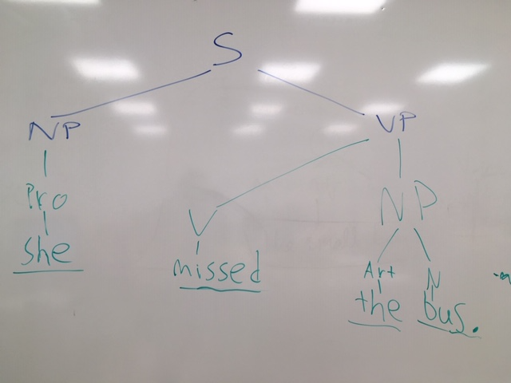

I started a new show
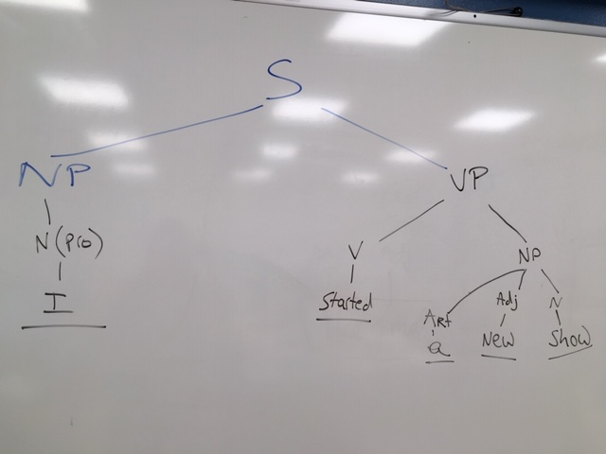

Jack sleeps on the bed
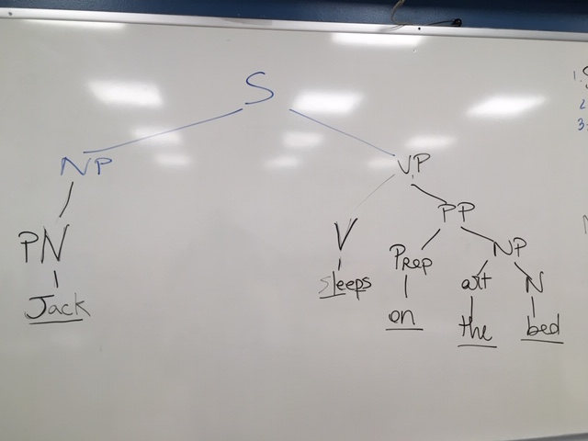

She will go to school
