Getting Started: Joining our Online Class Community
In order to create a blog you will first need to sign up for an account at qwriting.qc.cuny.edu, which you can do by following this link: cunyhumanitiesalliance.org. Please keep the following in mind as you fill out the registration form:
- You can enter any Username and Password that you wish, or leave the Password field blank to have one automatically generated. Once created, your Username cannot be changed. The blog will also create a Display Name for you based on your Username, which will appear next to your posts and comments. When you log into cunyhumanitiesalliance.org for the first time, it’s recommended that you change your Password to something memorable, if it was randomly generated, and your Display Name to something more recognizable. You can do both by logging into your Dashboard, then clicking Users > Your Profile. The Dashboard is explained in more detail in the next section of the help site, for those who are not familiar with the interface.
- You’ll need to use your @lagcc.cuny.edu email address to sign up for an account. This is to prevent people who are not members of the LAGCC community from creating blogs on the CUNYHums server. Once you have signed up for an account, you will be able to change your email address in your User Profile. You can access this by logging into your Dashboard, then clicking Users > Your Profile.
- A radio button at the bottom of the signup page will allow you to just create an account, or create both an account and a blog. Some users, such as students enrolled in a class in which everyone is posting to a single blog created by the professor, for example, may only want to create an account and not a blog. Once you have created an account, you may create as many additional blogs as you wish at any time.
- Once you’ve signed up, you’ll receive an email asking you to activate your account (check your spam folder if you don’t see the email). Click the link to activate your account.

How to Write and Publish a Post
(from http://help.qwriting.qc.cuny.edu/how-to-write-and-publish-a-post/ (includes a nifty video!)
1. From the Dashboard, go to Posts > Add New in the menu on the left. Or choose Post in the Add New dropdown in the toolbar at the top of the screen.
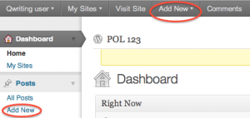
2. Add a title and content to your post. You will notice that many of the formatting buttons look similar to those in common word processing and email software, and work the same way. Simply highlight the text you want to modify, and click the appropriate button to change the style of the font or formatting of the text. If you only see one line of buttons, click the button shown below for additional formatting options.

3. Images, audio, and video can be included in the post using the Upload/Insert buttons at the upper left of the Text Editor. Detailed instructions on adding various types of media are covered here (images), here (audio and video), and here (documents).

4. To the right of the Text Editor is the Publish window. WordPress will periodically do an auto-save, but it might be a good habit to click Save Draft every now and again to ensure you don’t lose anything. You can also choose Save Draft if you’d like to close your post and continue working on it later without making it visible to the public. If you’d like to see how your post will appear to users before you publish it, you can click the Preview button.

5. Privacy settings are determined by the post’s Visibility. Clicking on the Visibility Edit link in the Publish box will allow you to make the post 1) public and accessible to all users, 2) Password Protected and available only to users who enter a password of your choosing, or 3) Private, and accessible only to users who have editor or administrator access to your blog. Students should check with their professors before making a post private.

6. Consider choosing a category for your post, or attaching tags to it, to make it easier for readers to navigate in the future.
When you’re ready for it to go live, click Publish.
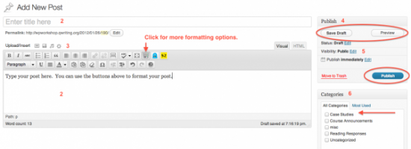

7. After you publish your post, you will see a notification that it has been published and you can now view the post, or navigate away from this screen without losing any of your work.

